Assignment -3

Assignment Date | 07 October 2022
Student Name | Kaavya S
Student Roll Number | 111519205017
Maximum Marks | 2 Marks

Question 1:

Create a bucket in IBM object Storage.

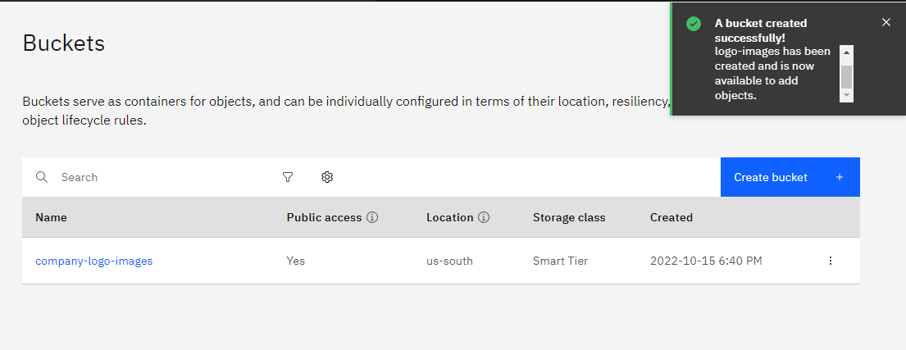
Question 2:

Upload any 5 images to IBM object storage and make it public. Write HTML code to display all the 5 images.

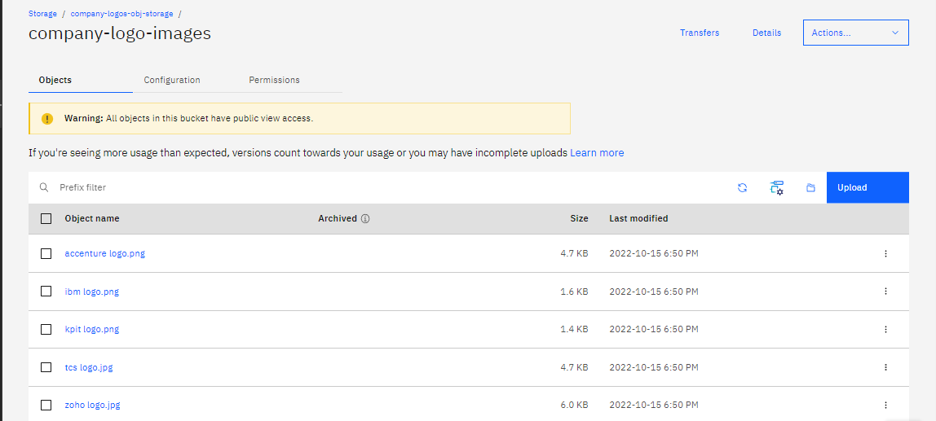

HTML code for displaying images in cloud2 :-

<!DOCTYPE html>
<html lang="en" dir="ltr">
<head>
<meta charset="utf-8">
<title>company logos</title>

</head>
<style>
body{
text-align: center;
background-color:rgb(253, 51, 206);

}
h2{
color: black;
font-size: 50px;

}
h1{
color:black;
text-align: center;
font-size: 75px;

}
img{
height : 230px;
width: 430px;
}
</style>
<body>
<h1>Popular company logos</h1>
<h2>Ibm</h2>
<img src="https://company-logo-images.s3.us-south.cloud-object-storage.appdomain.cloud/ibm%20logo.png" alt="ibm">
<h2>Accenture</h2>
<img src="https://company-logo-images.s3.us-south.cloud-object-storage.appdomain.cloud/accenture%20logo.png" alt="Accenture logo">
<h2>Zoho</h2>
<img src="https://company-logo-images.s3.us-south.cloud-object-storage.appdomain.cloud/zoho%20logo.jpg" alt="zoho">
<h2>Kpit</h2>
<img src="https://company-logo-images.s3.us-south.cloud-object-storage.appdomain.cloud/kpit%20logo.png" alt="kpit">
<h2>Tcs</h2>
<img src="https://company-logo-images.s3.us-south.cloud-object-storage.appdomain.cloud/tcs%20logo.jpg" alt="tcs">
</body>
</html>

HTML Output for displaying images from IBM cloud storage: 4-

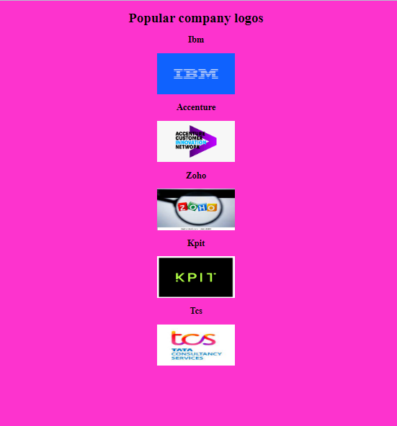

Question 3:

Upload a CSS page to the object storage and use the same page in your HTML code. HTML code with CSS file present in IBM cloud storage.

Style.css code:

body{
background-color: aliceblue;
}
h1{
text-align: center;
color: brown;

}
p{
color: whitesmoke;
text-align: center;
}

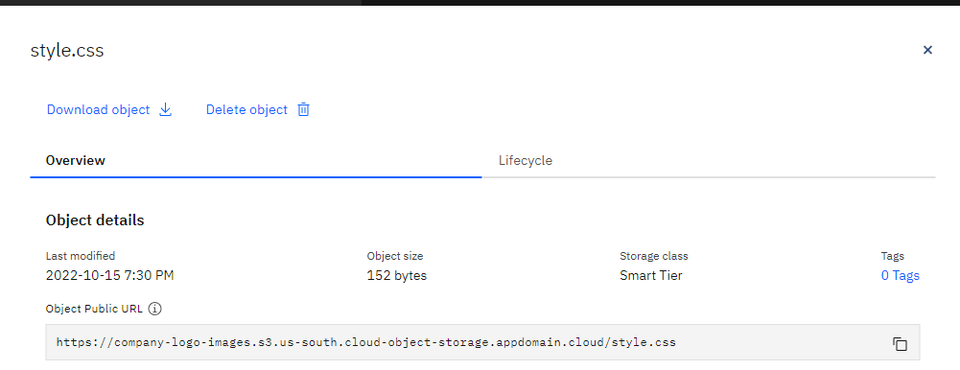

HTML code:

<html>
<head>
<title>Home page</title>
<link rel="stylesheet" href="https://company-logo-images.s3.us-south.cloud-object-storage.appdomain.cloud/style.css">

</head>
<body>
<h1>Hello</h1>
<h3>Lets look upon thes css file containing IBM cloud storage<a href="https://company-logo-images.s3.us-south.cloud-object-storage.appdomain.cloud/style.css">click here</a></h3>

</body>
</html>

HTML code output:

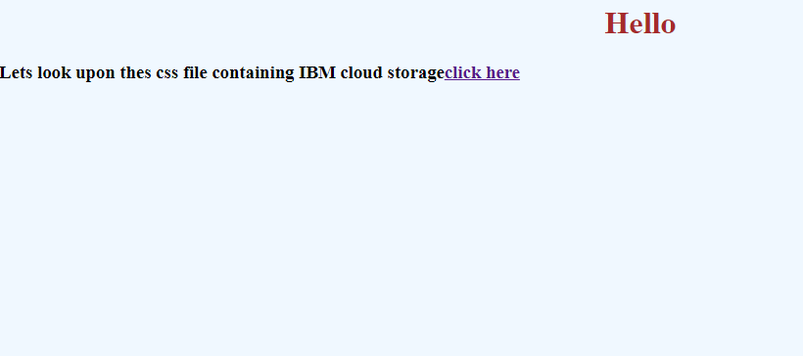

Design a chatbot using IBM Watson assistant for hospitals. Ex: User comes with a query to know the branches for that hospital in your city. Submit the web URL of that chat bot as an assignment.

URL for the Chat Bot :

https://web-chat.global.assistant.watson.appdomain.cloud/preview.html?backgroundImageURL=https%3A%2F%2Fus-south.assistant.watson.cloud.ibm.com%2Fpublic%2Fimages%2Fupx-41fd19c7-5c1e-4f7d-a76e-e7dc4ab91de9%3A%3Ab1f9a53e-bf29-425b-9906-cb88a17fdf86&integrationID=f4828607-0c90-4be4-a027-206601a1214d&region=us-south&serviceInstanceID=41fd19c7-5c1e-4f7d-a76e-e7dc4ab91de9

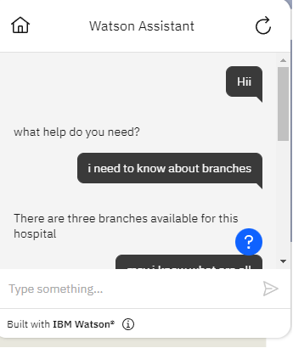

\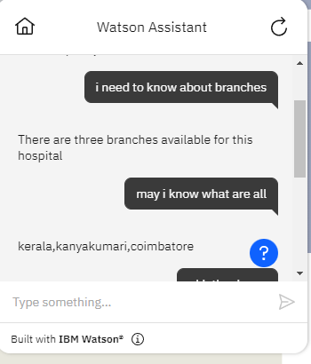

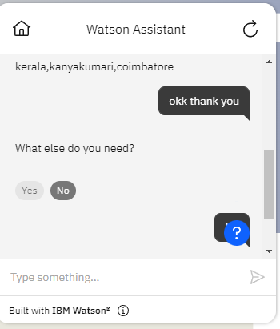

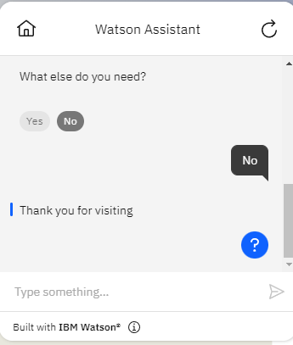

Create a Watson assistant service with 10 steps and use 3 conditions in it. Load that script in the
HTML page.

HTML CODE:
<!DOCTYPE html>
<html lang="en">
<head>
<meta charset="UTF-8">
<meta http-equiv="X-UA-Compatible" content="IE=edge">
<meta name="viewport" content="width=device-width, initial-scale=1.0">
<title>Chat bot</title>
<style>
h1{
text-align: center;
color: #ffffff;
}
body{
background-color: #000000;
} input[type="text"],input[type="password"]{ height: 42px;
width: 400px;
font-family: cursive;
border-radius: 100px;
background-color:rgb(237, 15, 193) ;
} input[type="submit"]{ height: 42px;
width: 100px;
color: #000;
background-color: rgb(25, 14, 236);
font-size: medium ; margin-top: 20px; border-radius: 50px;
}
p{
color: #ffffff;
font-size: 28px;
}
form{
text-align: center;
}
small{
color: #ffffff;
}
img{
fill: auto;

}
</style>
</head>
<body>
<h1>KaavyaSenthil Welcomes you!!!</h1>
<h1>login to your account</h1>
<form>
<p>Enter-Username </p>
<input type="text" >
<br><br>
<p>Enter-Password </p>
<input type="password">
<br><br>
<input type="submit" value="login" >
<br><br>
<small>Click here to browse more <a href="https://www.youtube.com/watch?v=E40UEoa19As"> info</a></small>
</form>
<script>
window.watsonAssistantChatOptions = {
integrationID:"4d39fa65-a7c4-4129-94ad-e0aa2d1c8e0b", // The ID of this integration.
region:"us-south", // The region your integration is hosted in.
serviceInstanceID:"41fd19c7-5c1e-4f7d-a76e-e7dc4ab91de9", // The ID of your service instance.
onLoad: function(instance) { instance.render(); }
};
setTimeout(function(){
const t=document.createElement('script');
t.src="https://web-chat.global.assistant.watson.appdomain.cloud/preview/"
+ (window.watsonAssistantChatOptions.clientVersion || 'latest') + "/WatsonAssistantChatEntry.js";
document.head.appendChild(t);
});
</script>
</body>
</html>

App.py code:

from flask import Flask, render_template

app = Flask(__name__)

@app.route("/")
def home():
return render_template("index.html")

@app.route("/salvador")
def salvador():
return "Hello, Salvador"

if __name__ == "main":
app.run(debug=True)

HTML CODE OUTPUT:

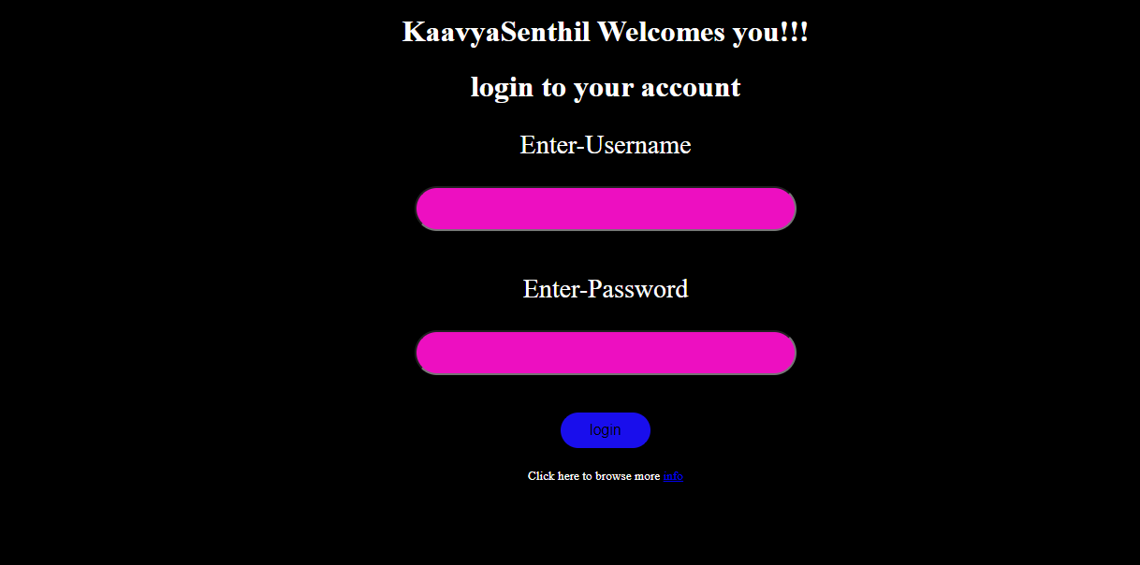
ASSISTANT OUTPUT:

